EXPT NO: 9 | Recommendation Systems using Collaborative Filtering Techniques
DATE: 13.03.2026

PRE-LAB QUESTIONS (PROVIDE BRIEF ANSWERS TO THE FOLLOWING QUESTIONS)
- What is a Recommendation System?
A recommendation system is a software technique used to suggest relevant items such as movies, products, songs, or books to users based on their preferences, behaviour, or similarities with other users. It helps reduce information overload and improves user experience by predicting what users are likely to prefer or interact with.

- What is Collaborative Filtering?
Collaborative filtering is a recommendation technique that predicts user preferences by analysing past interactions, ratings, or behaviours of many users. It assumes that users with similar tastes in the past will prefer similar items in the future. It does not require detailed item features, only user-item interaction patterns.

- Difference between User-Based and Item-Based Collaborative Filtering?
User-based collaborative filtering recommends items by finding users with similar preferences and suggesting what they liked. Item-based collaborative filtering recommends items by finding products or content similar to those a user already liked. User-based focuses on similar users, while item-based focuses on similar items and is often more scalable.

- What is a User-Item Interaction Matrix?
A user-item interaction matrix is a table where rows represent users and columns represent items, and each cell shows interaction such as rating, click, purchase, or view. It is the basic data structure used in recommendation systems to identify user preferences and discover patterns for generating personalized suggestions.

- What is similarity in recommendation systems?
Similarity in recommendation systems measures how closely users or items are related based on ratings, behaviour, or features. It helps identify users with similar interests or items with similar characteristics. This similarity score is essential for generating recommendations, especially in collaborative filtering methods where prediction depends on related users or items.

- What are cosine similarity and Pearson correlation?
Cosine similarity measures the angle between two vectors and is used to compare users or items based on rating patterns. Pearson correlation measures the linear relationship between two variables by considering rating differences from the average. Both are popular similarity measures used in collaborative filtering recommendation systems.

- What is the cold-start problem?
The cold-start problem occurs when a recommendation system has insufficient data about new users or new items, making it difficult to generate accurate recommendations. Since collaborative filtering depends on past interactions, lack of ratings or behaviour history reduces performance. It is a common challenge in real-world recommender systems.

- Difference between Content-Based and Collaborative Filtering?
Content-based filtering recommends items by analysing item features and matching them with a user’s past preferences. Collaborative filtering recommends items based on behaviour and preferences of similar users or similar items. Content-based depends on item attributes, while collaborative filtering depends mainly on user-item interaction patterns and shared behaviour.

SCENARIO 1 – USER-BASED COLLABORATIVE FILTERING

Problem Statement
Recommend movies to users based on similar users' preferences.

Dataset (Kaggle – Public)
MovieLens Dataset
Dataset Link: https://www.kaggle.com/datasets/grouplens/movielens-100k
(You can pick any dataset if required)

Target Variable: Recommended movies for a given user
Input Feature:
• User ID
• Movie ID
• Ratings
• Timestamp

IN-LAB TASKS (KNN Classification)
- Import required Python libraries
- Load the MovieLens dataset
- Perform data inspection & preprocessing
- Create User-Item matrix
- Handle missing values (fill with 0 or mean)
- Compute similarity between users (Cosine similarity)
- Identify top-N similar users
- Predict ratings for unseen movies
- Generate Top-N recommendations for a user
- Evaluate using:
- RMSE (Root Mean Square Error)
- MAE (Mean Absolute Error)

Analysis Tasks
• Observe how similarity affects recommendations
• Analyze sparsity of the matrix
• Identify recommendation quality for different users

Visualization
• Heatmap of User-Item Matrix
• Similarity Matrix
• Top recommended movies
SCENARIO 2 – ITEM-BASED COLLABORATIVE FILTERING

Problem Statement
Recommend similar items (movies/products) based on user ratings.

Dataset (Same / Alternative Dataset)
MovieLens Dataset / Amazon Product Dataset

Target Variable: Recommended items similar to a given item
Input Features
• Item ID
• User ratings
• User interactions

IN-LAB TASKS (Decision Tree Classification)
  - Load dataset
  - Create Item-User matrix
  - Compute item similarity (Cosine similarity / Pearson correlation)
  - Identify top similar items
  - Recommend items based on user history
  - Compare item-based vs user-based recommendations
  - Evaluate model using:
- RMSE
- Precision@K

Analysis Tasks
• Compare recommendation accuracy with Scenario 1
• Identify popular vs niche items
• Study scalability of item-based approach

Visualization
• Item similarity heatmap
• Top similar items graph
• Recommendation comparison chart

Code & Output

Scenario 1
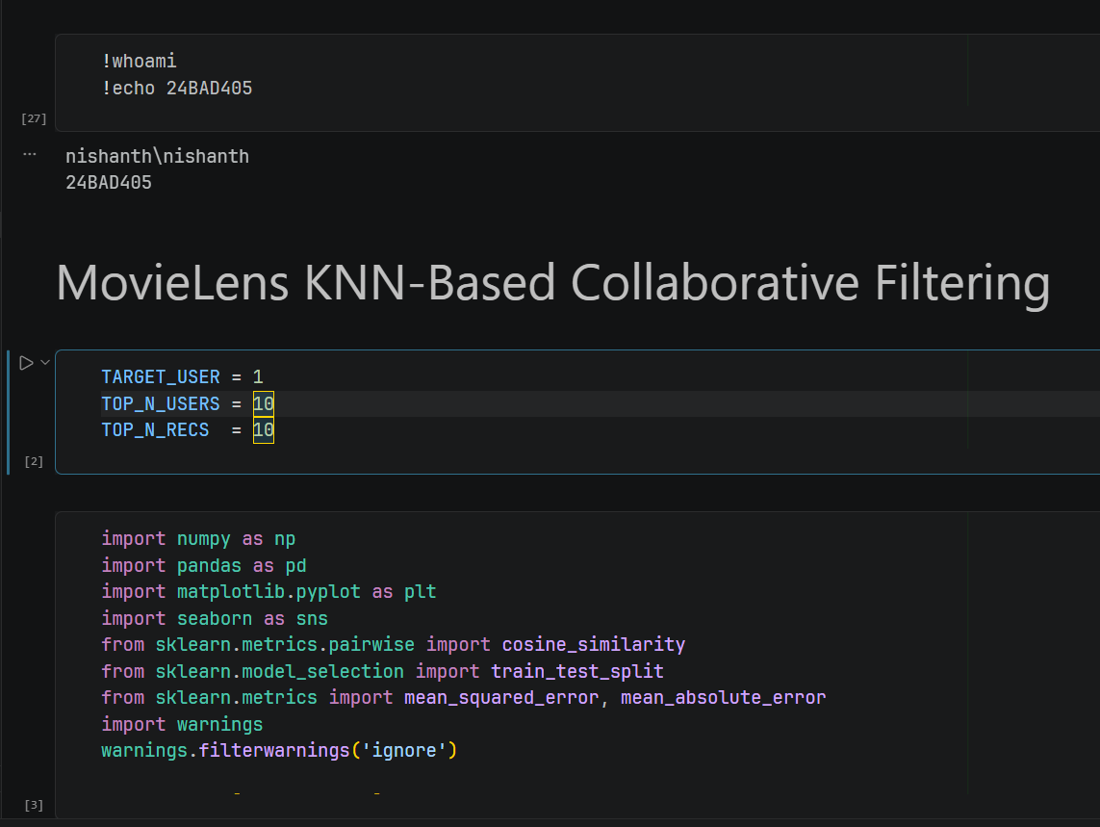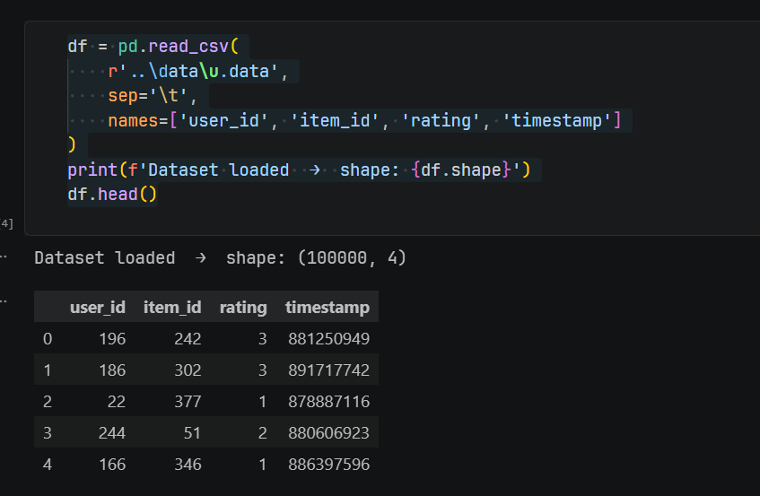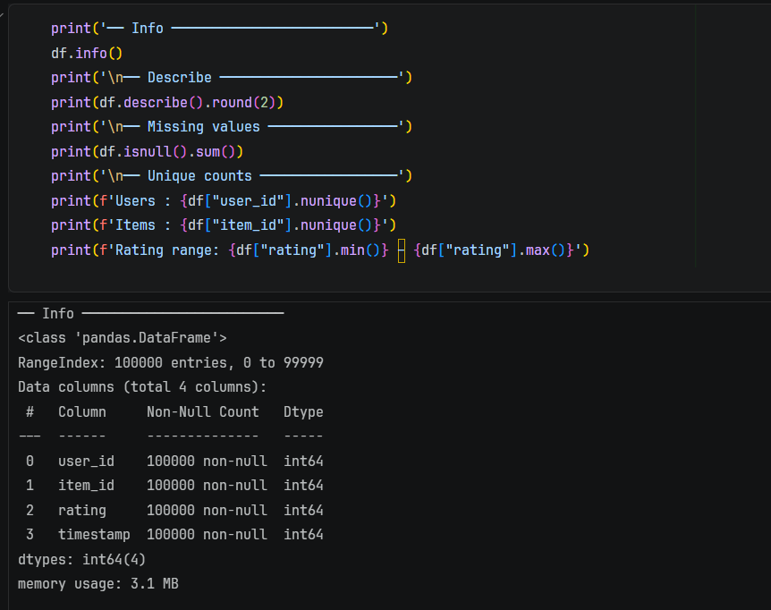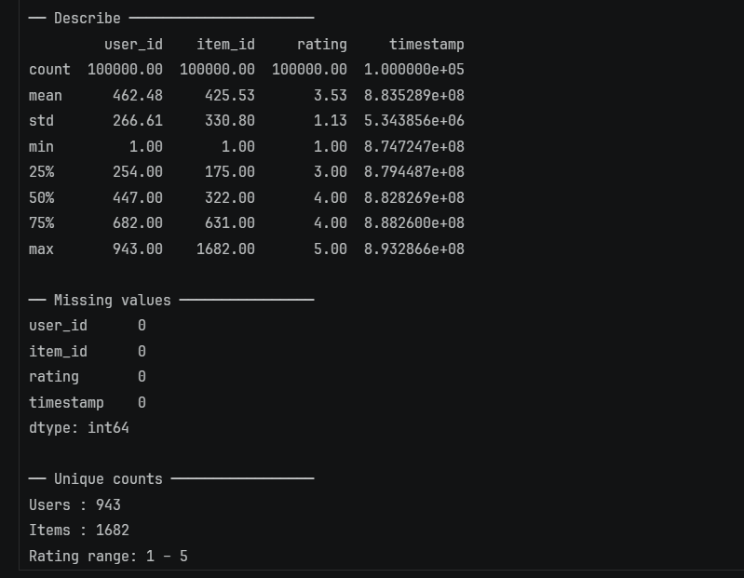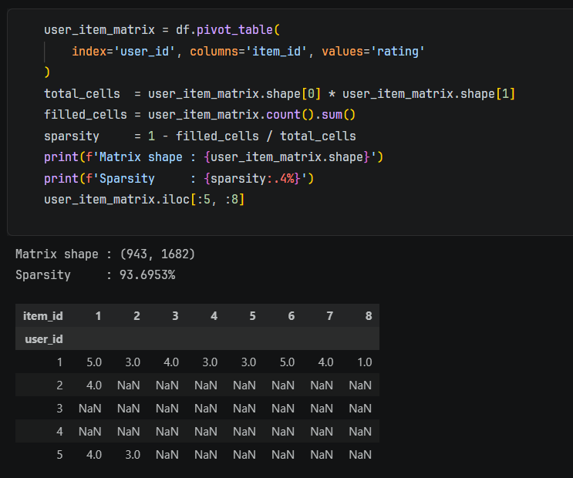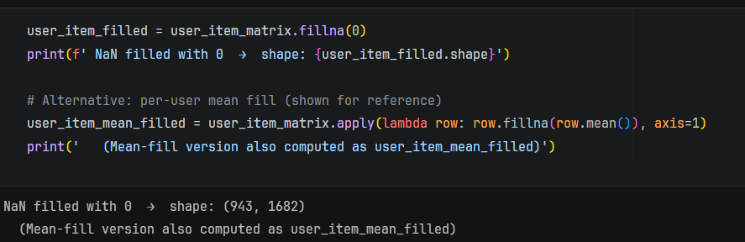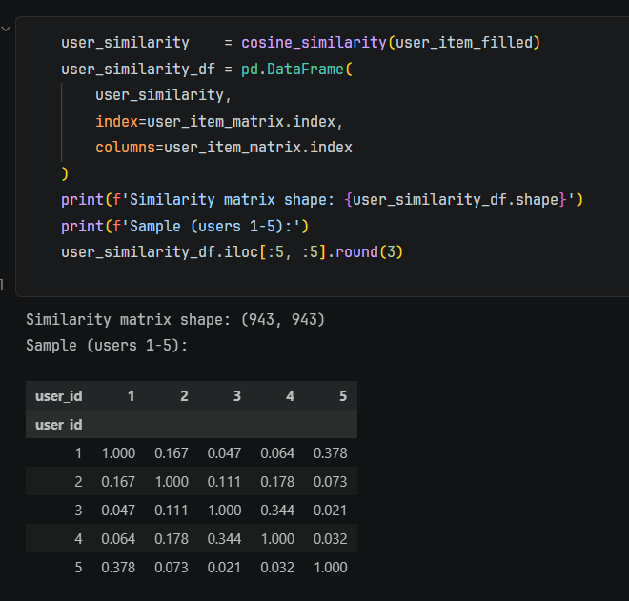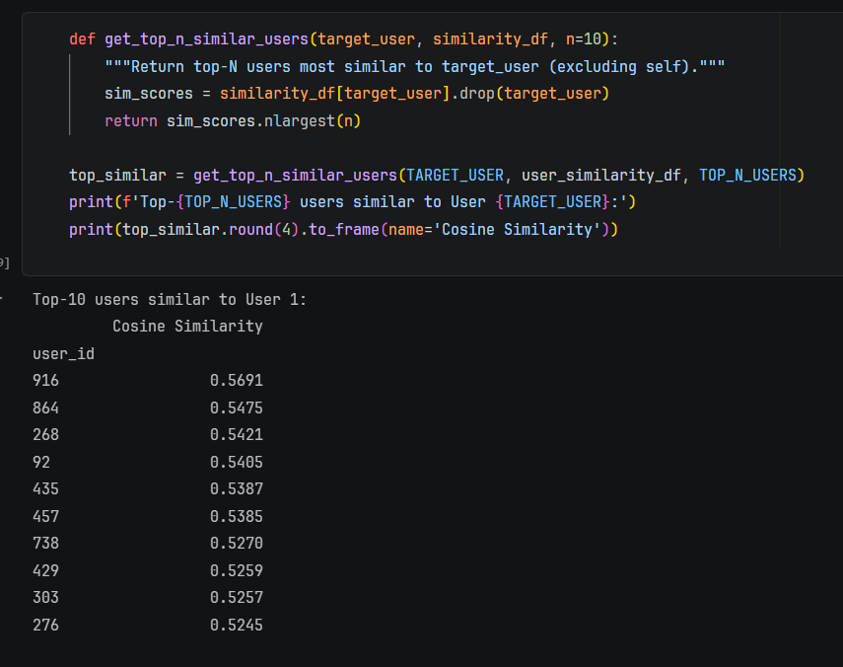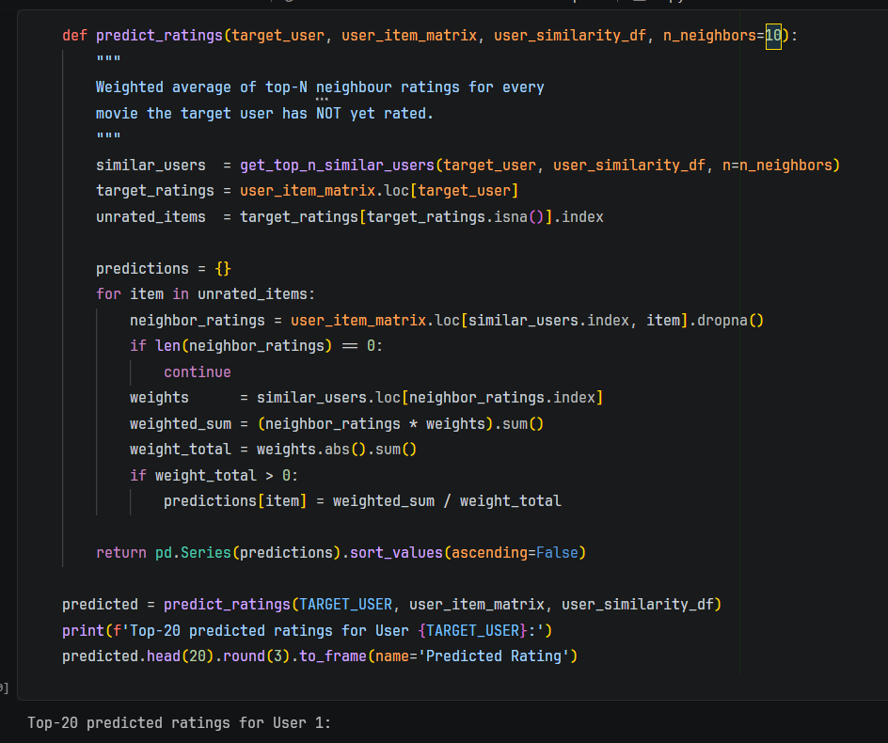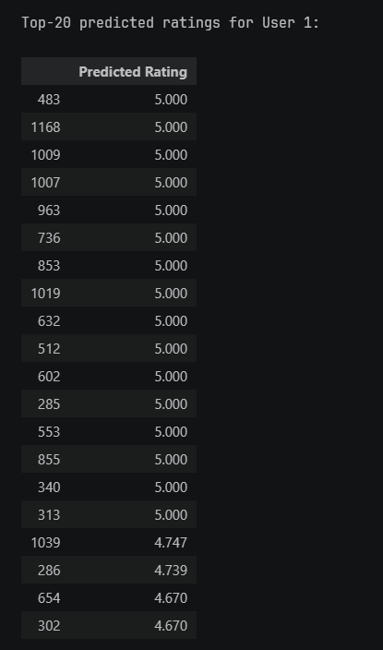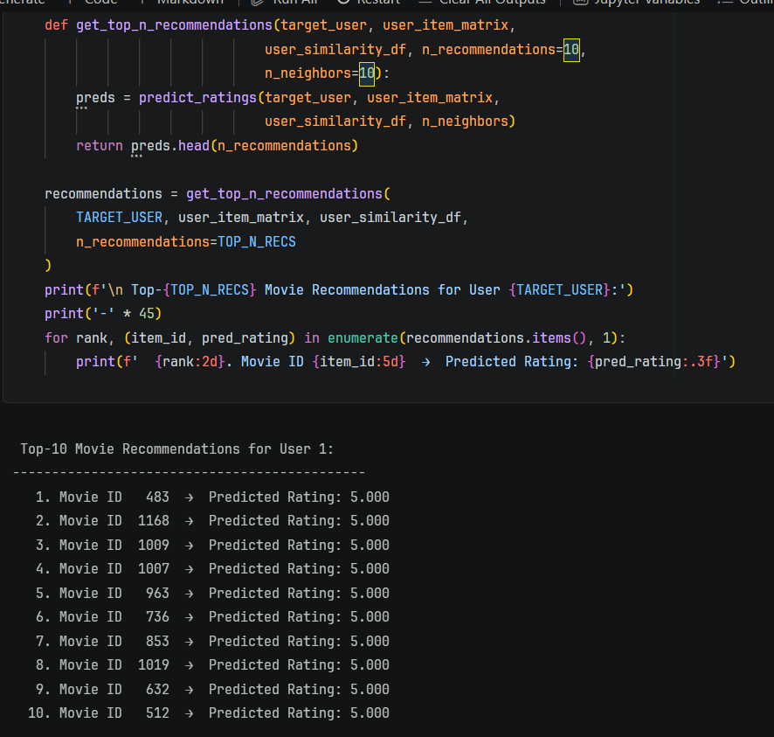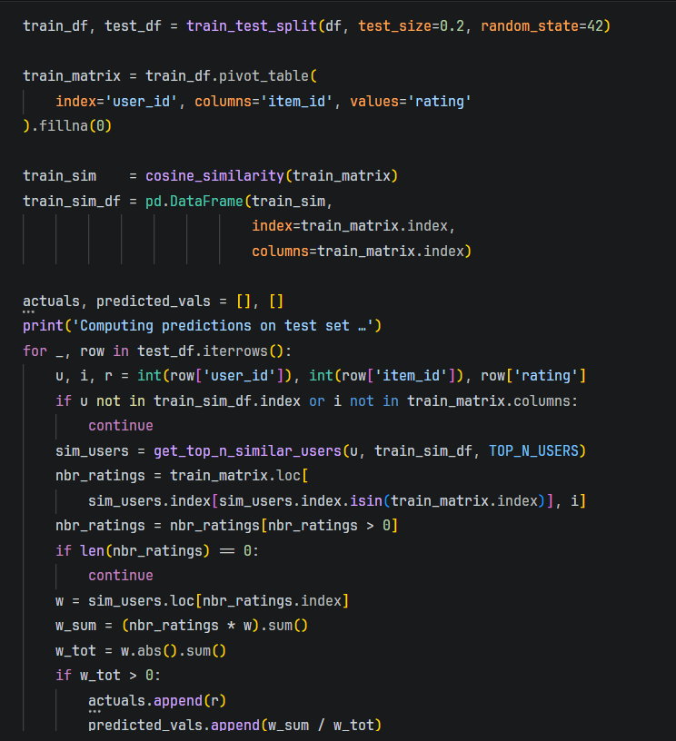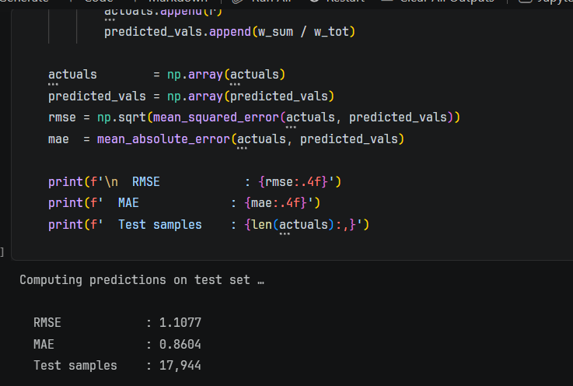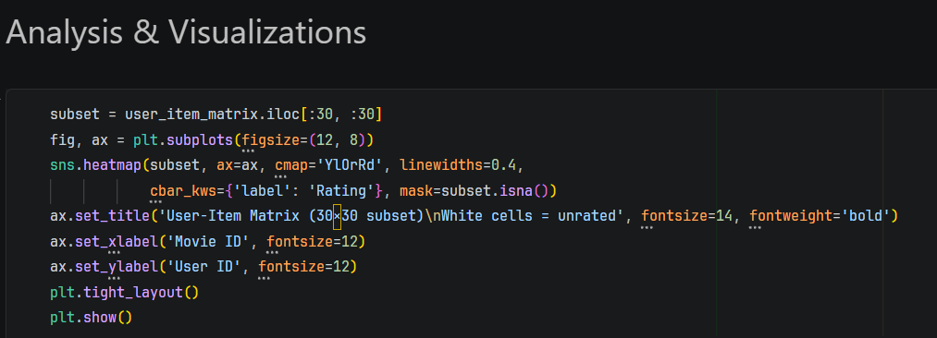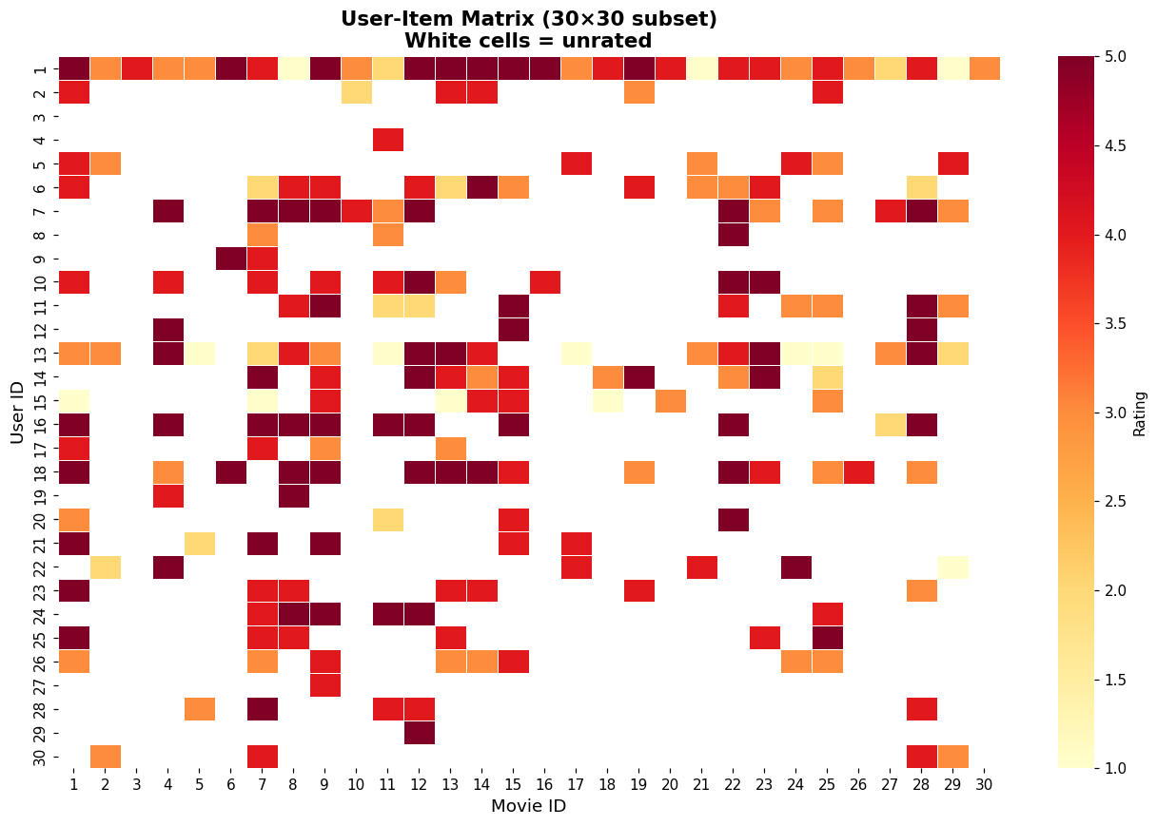
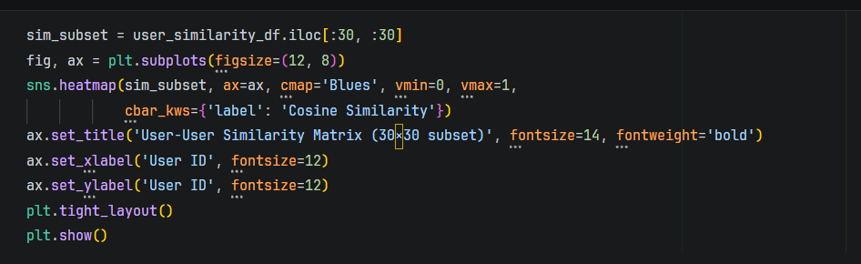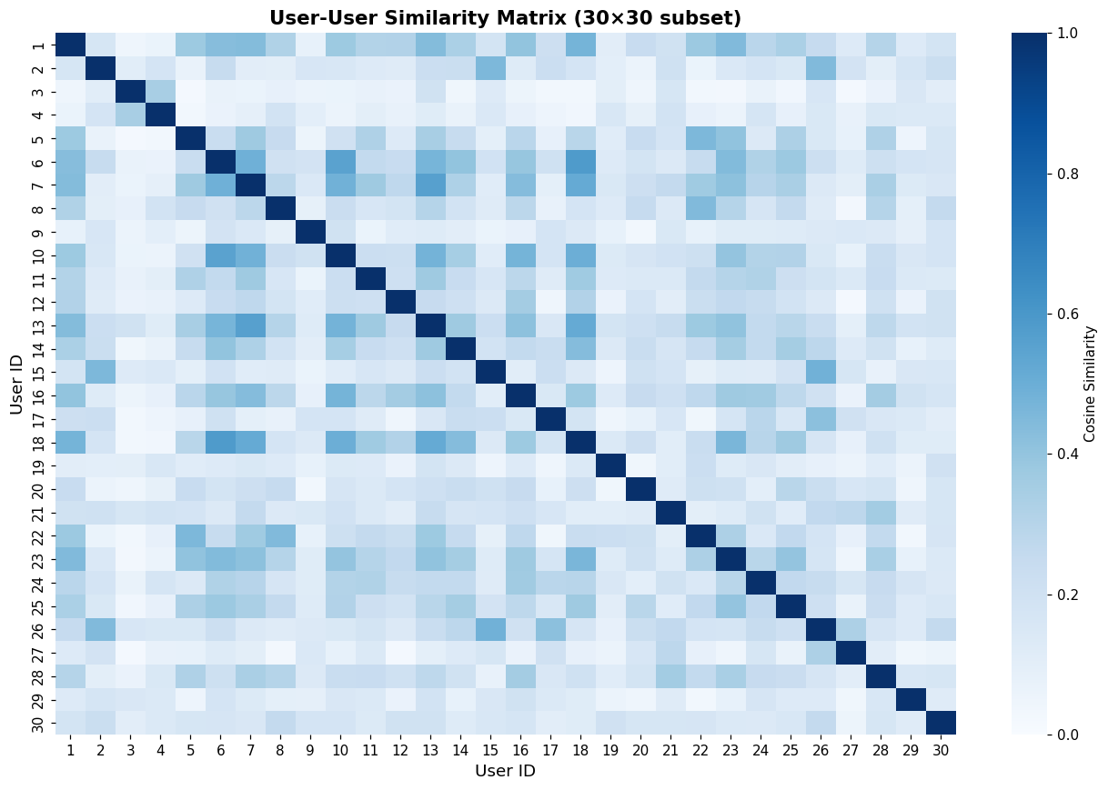
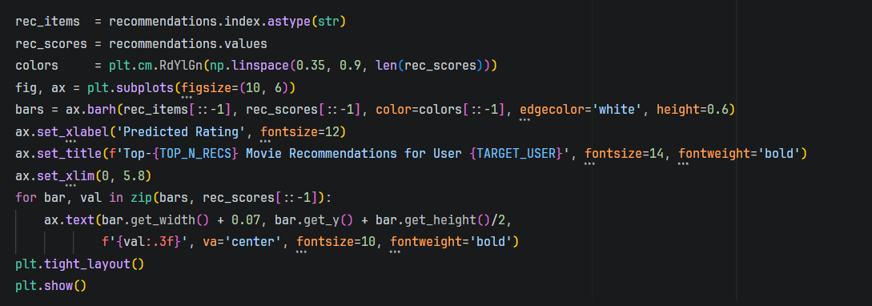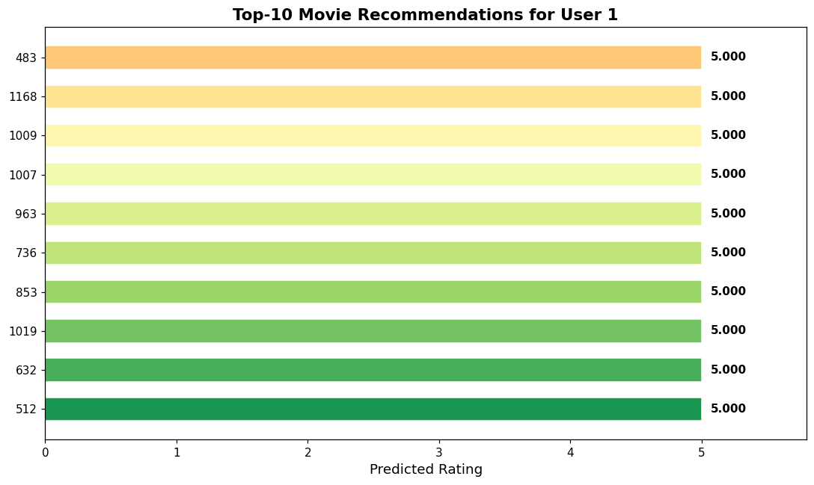
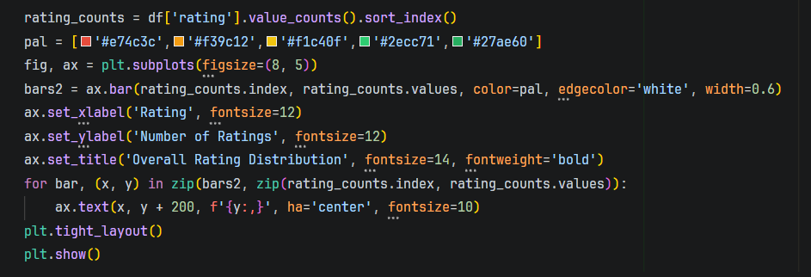
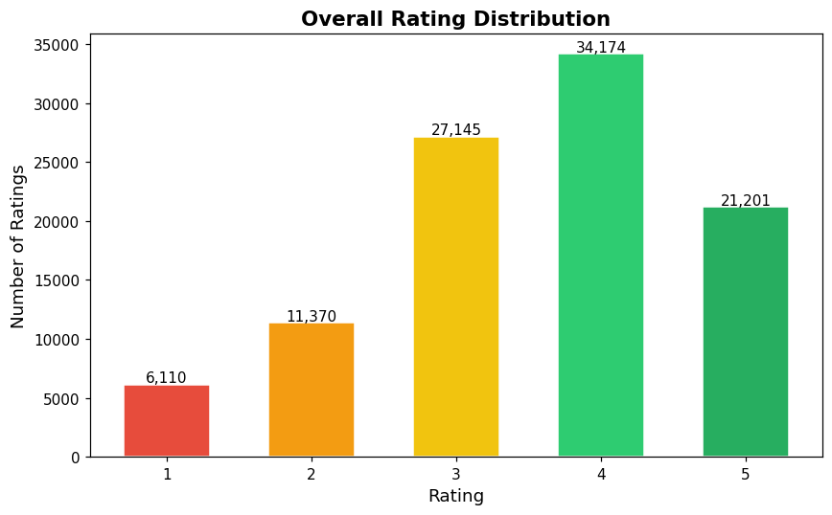
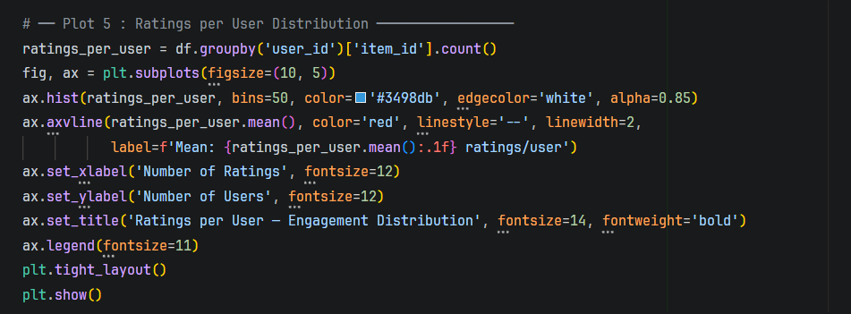
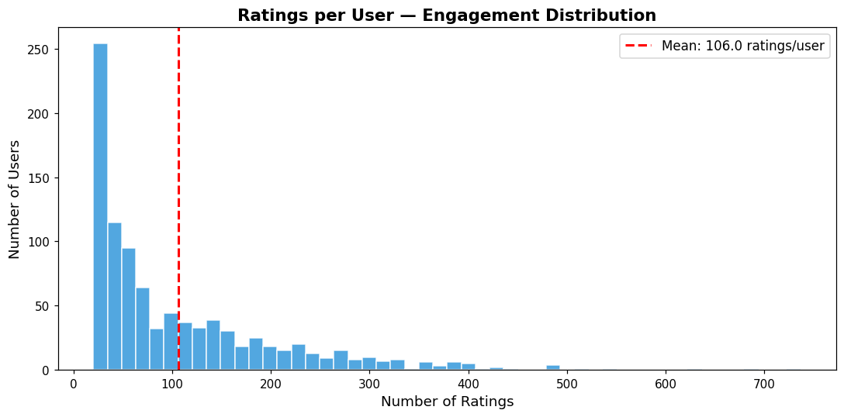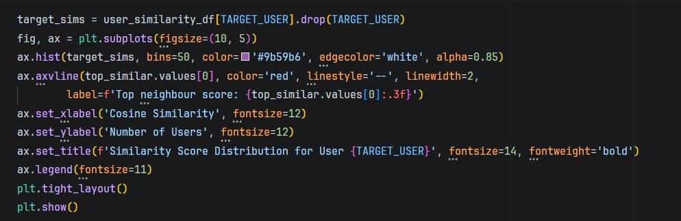
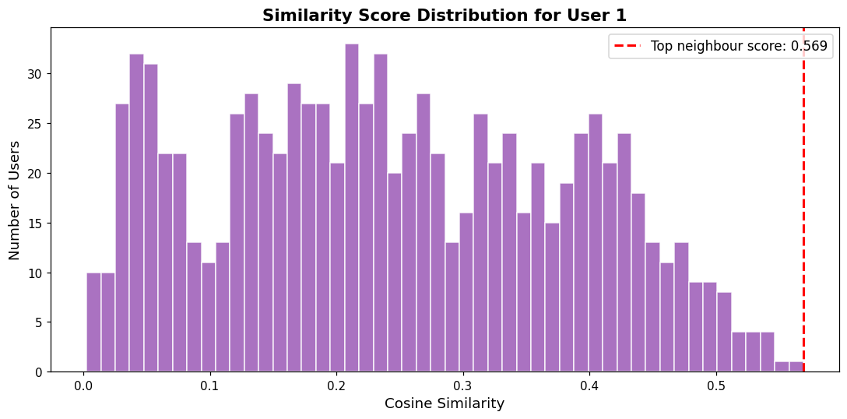
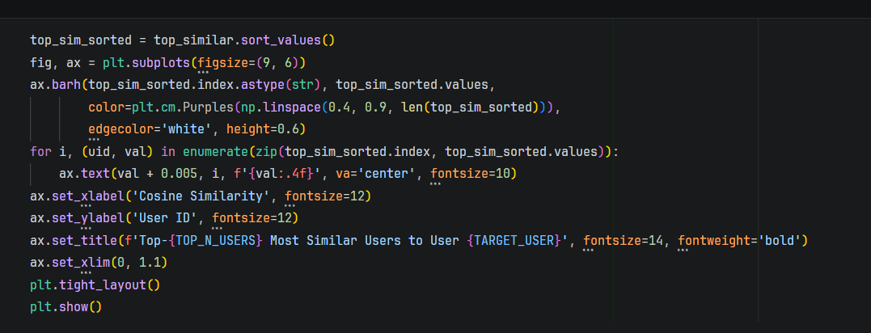
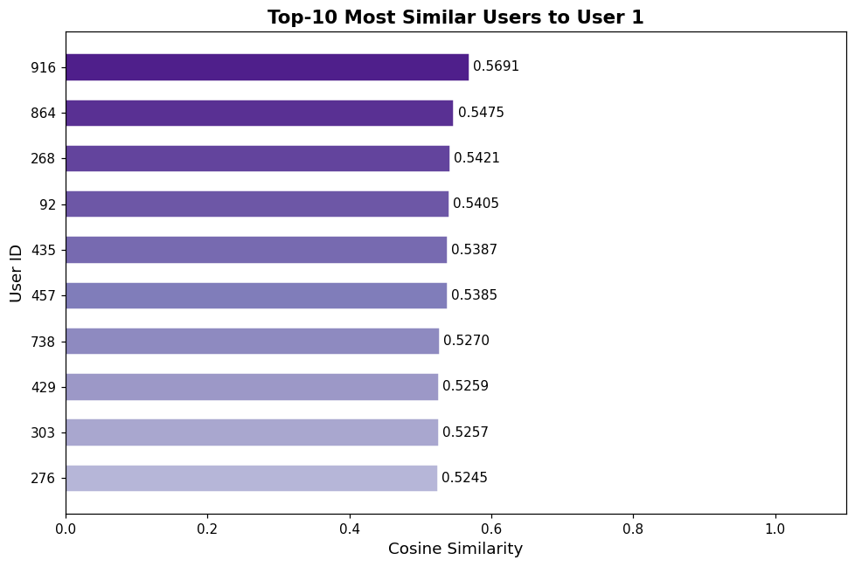
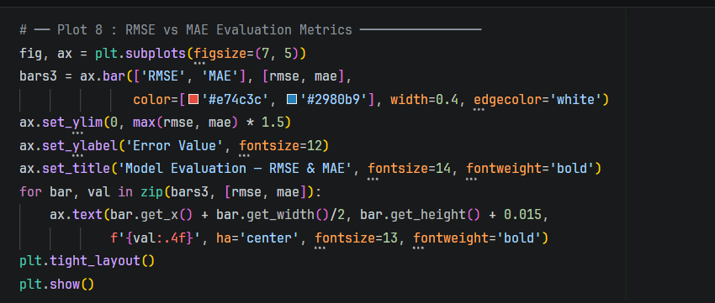
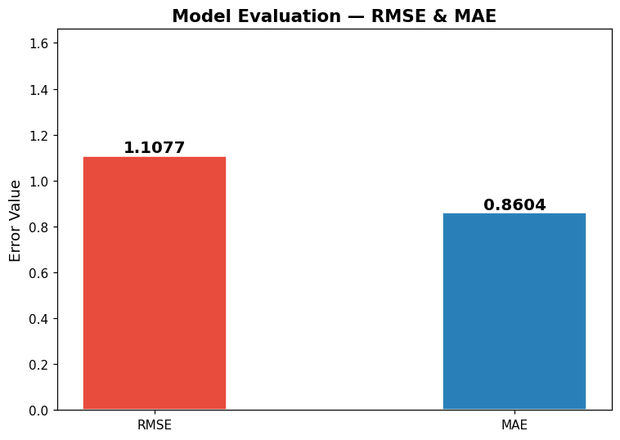
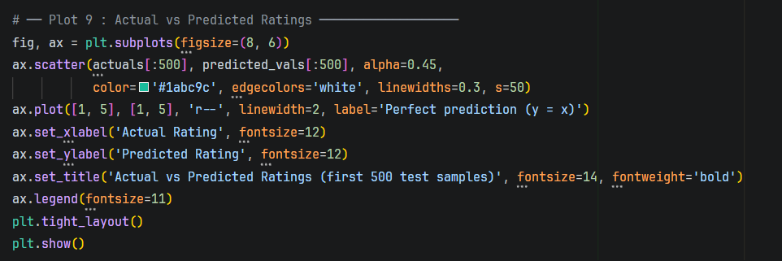
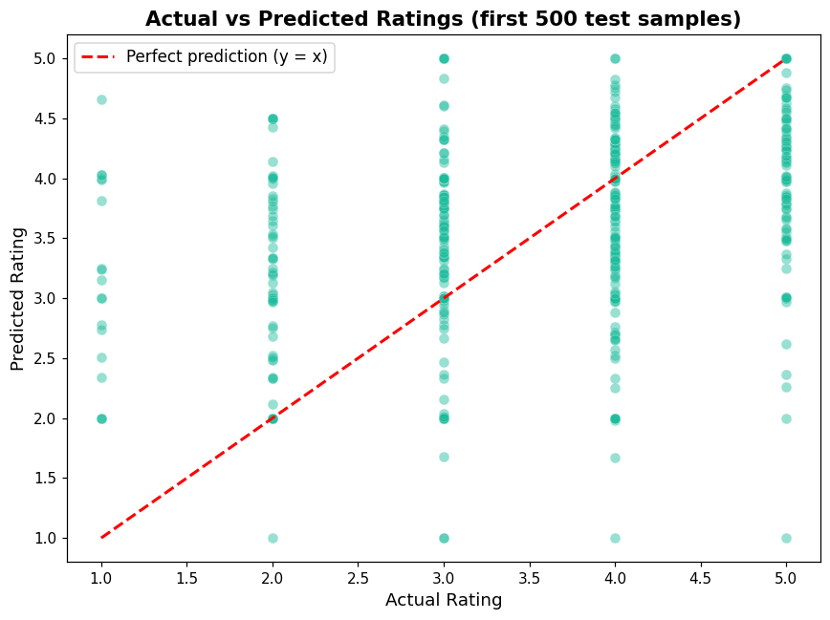
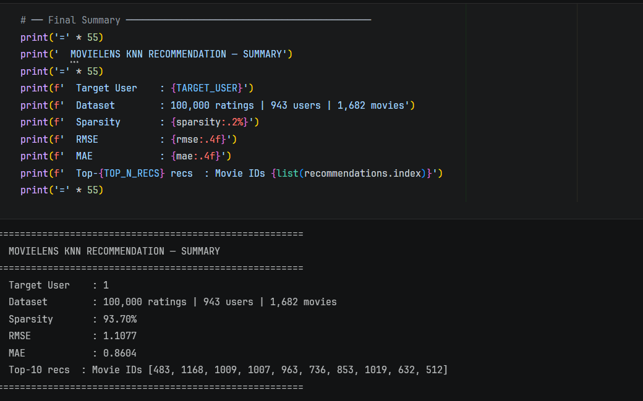

Scenario 2
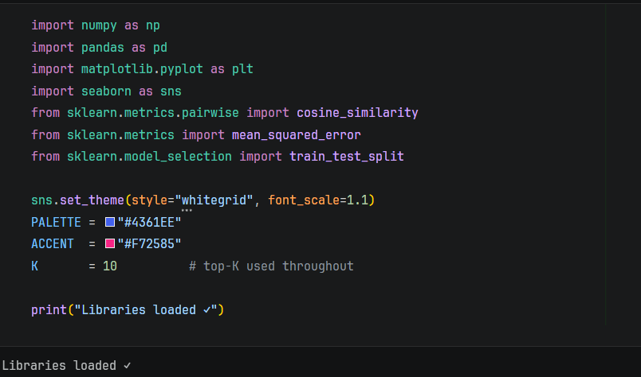
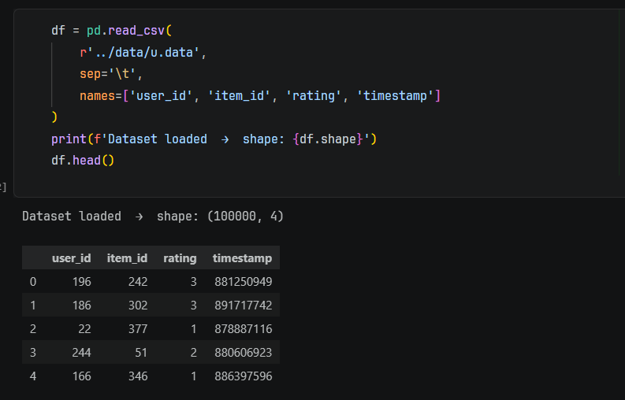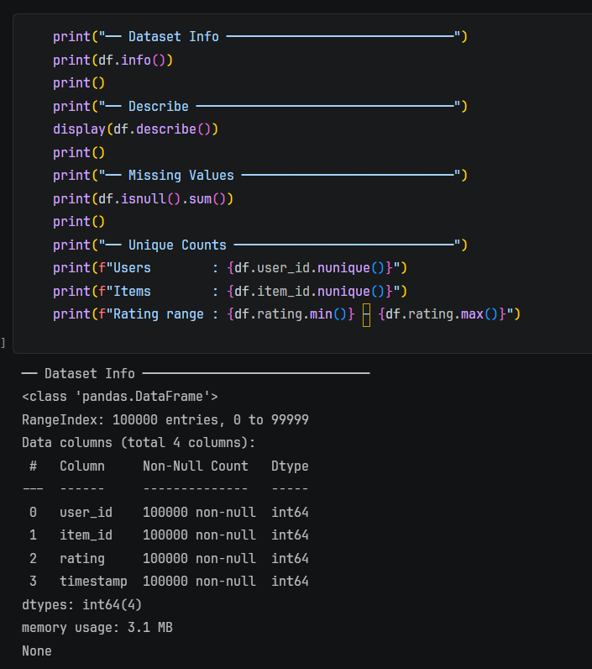
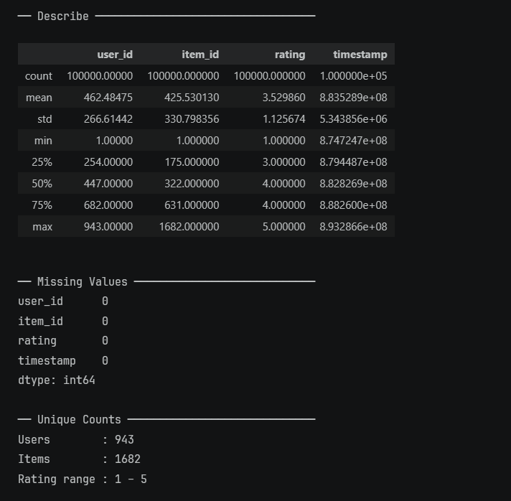
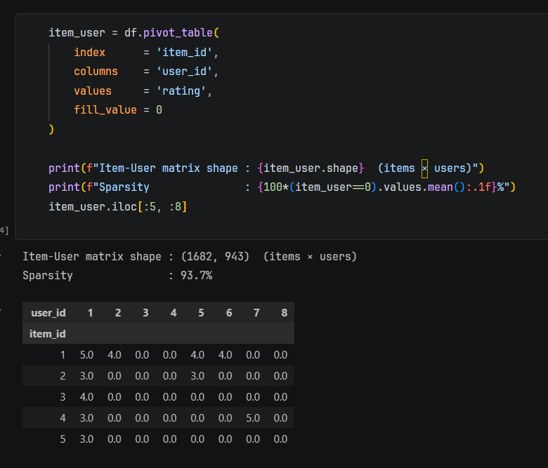
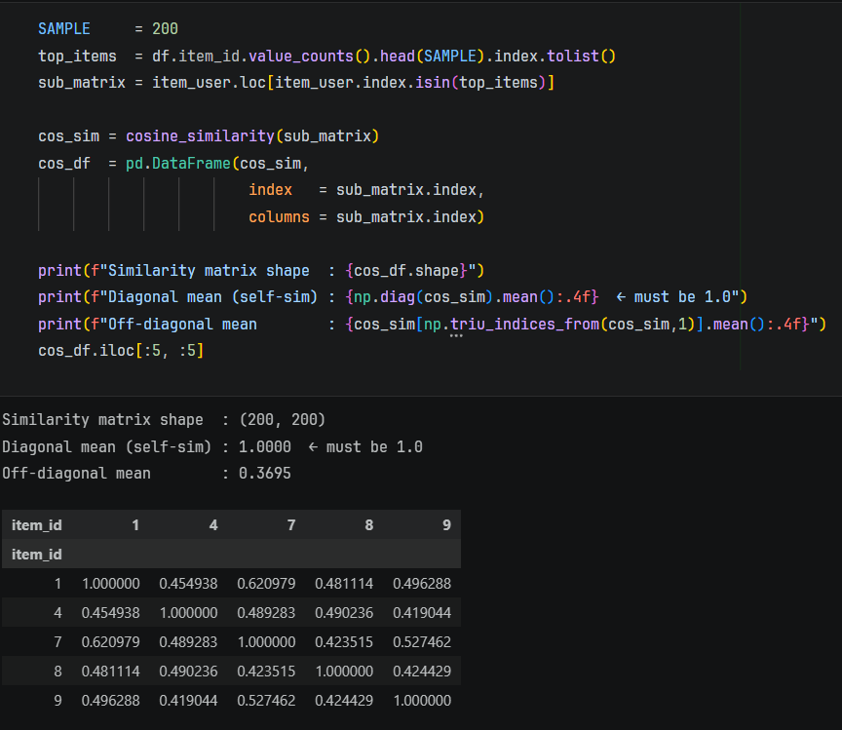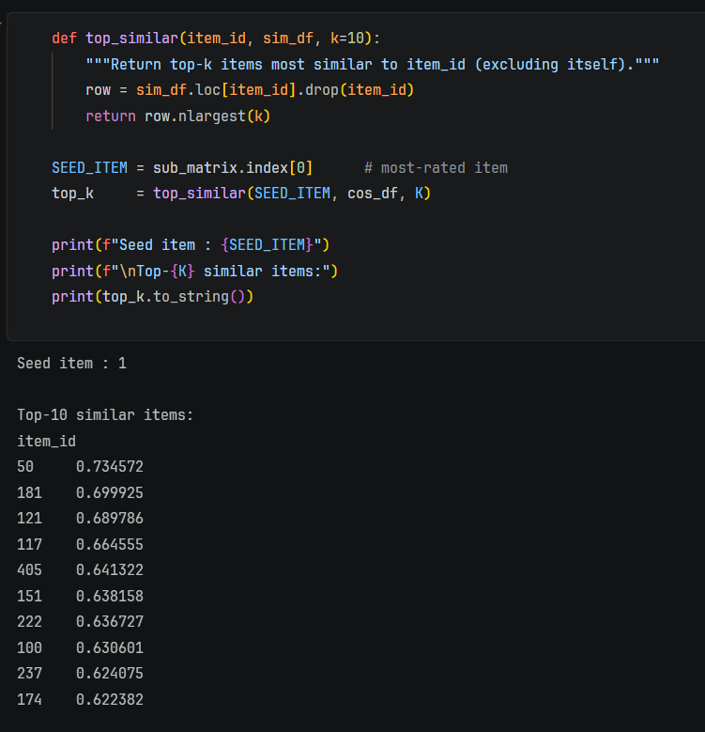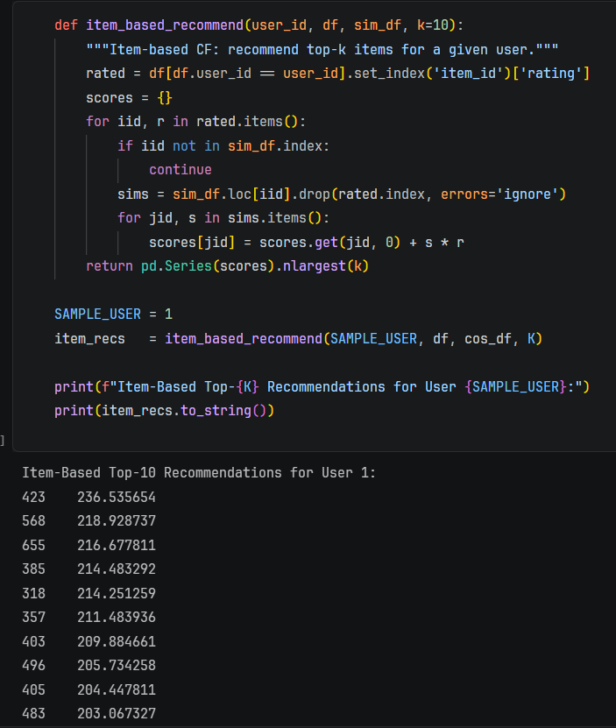
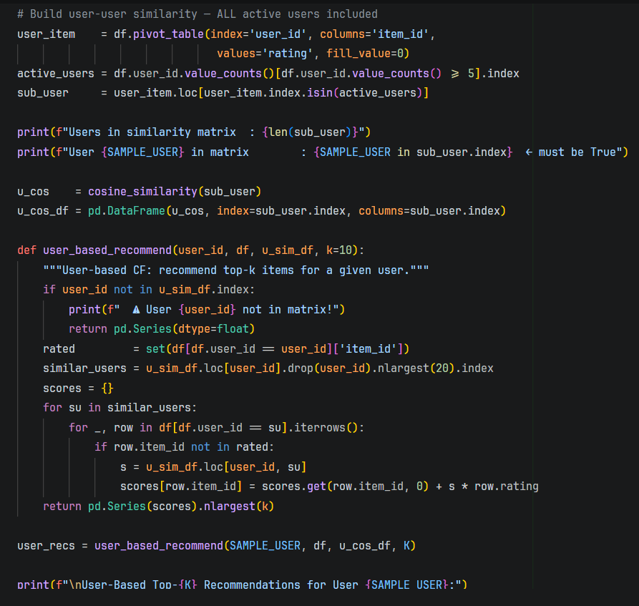
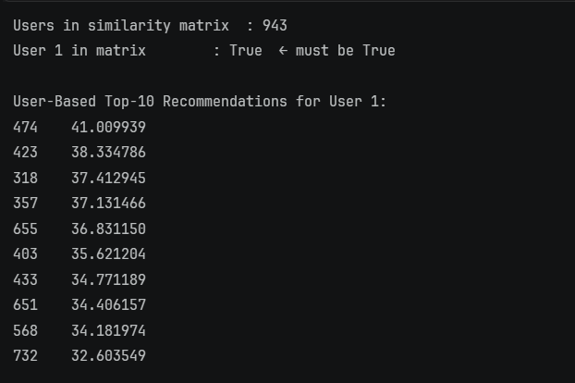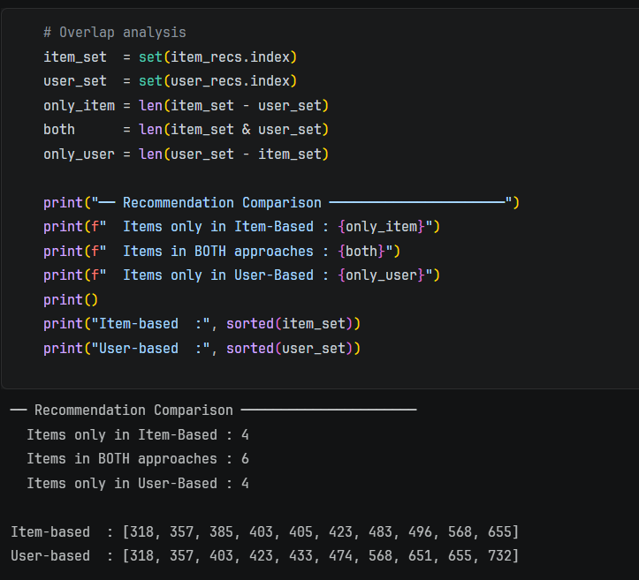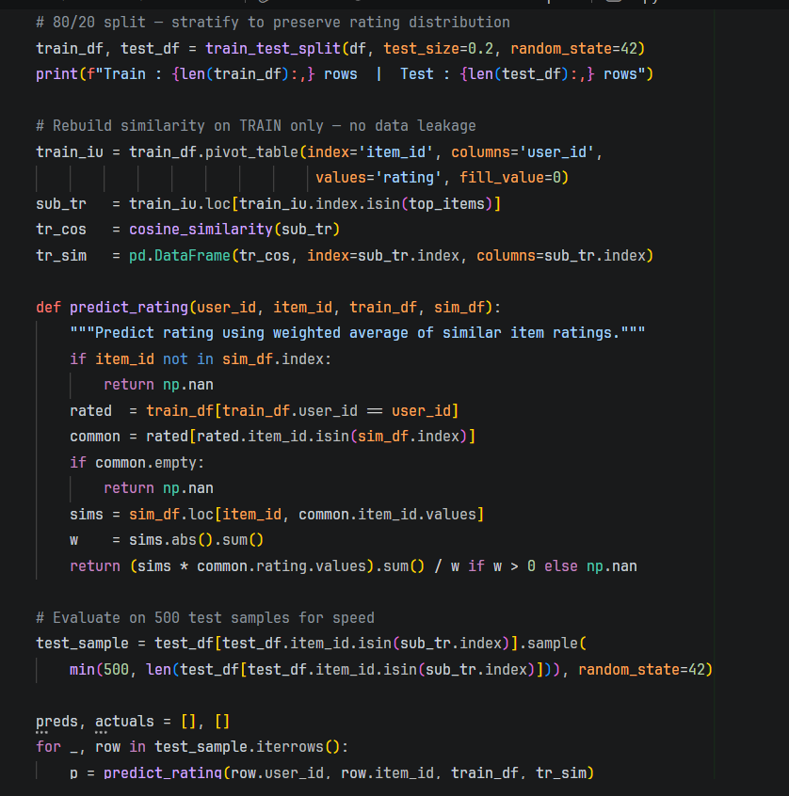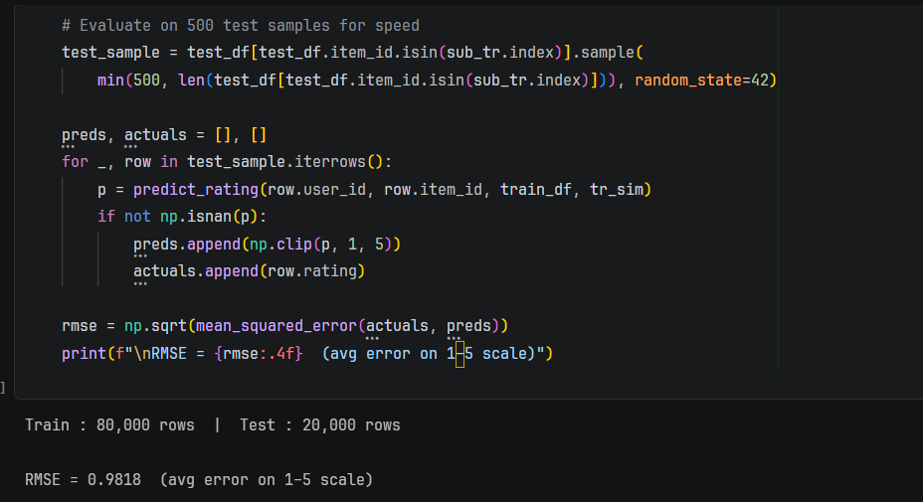
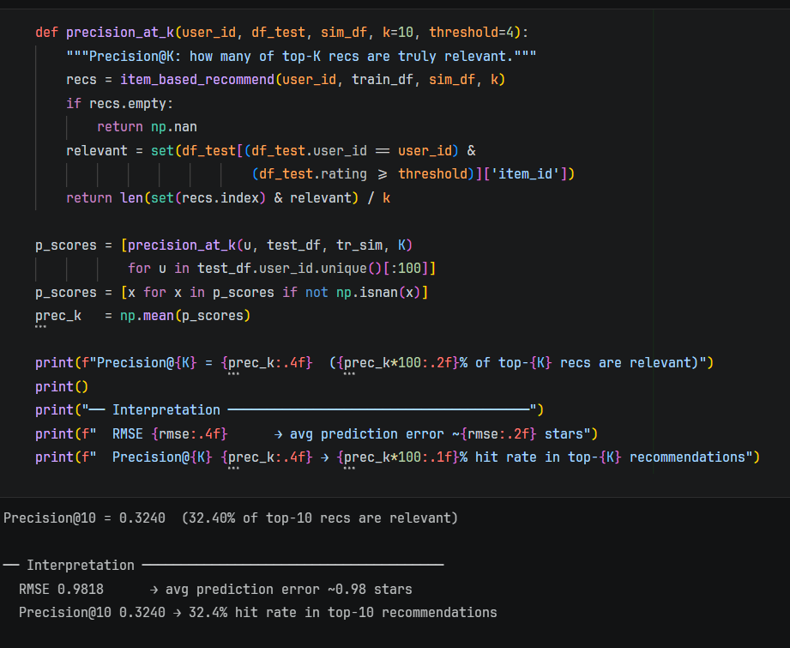

POST-LAB QUESTIONS (PROVIDE BRIEF ANSWERS TO THE FOLLOWING QUESTIONS)

Scenario 1 – User-Based CF
- How were similar users identified?
Similar users were identified using cosine similarity applied to the user-item rating matrix. Missing values were filled with zero, and users with the highest similarity scores to the target user were selected as nearest neighbours for generating recommendations.

- What challenges did sparsity introduce?
High sparsity (around 93%) led to very few common ratings between users, making similarity calculations unreliable. It also reduced prediction coverage, since many items lacked ratings from similar users, limiting the system’s ability to recommend effectively.

- How accurate were the recommendations?
The model achieved an RMSE of about 1.10 and MAE of 0.86, indicating moderate accuracy. Predictions were reasonably close to actual ratings, but noticeable errors remained due to sparse data and the simplicity of the user-based approach.

- Limitations of user-based filtering?
User-based filtering suffers from sparsity, cold start problems, and scalability issues. It depends heavily on neighbour ratings, may produce unreliable similarity scores, and often favours popular items, reducing diversity and overall recommendation quality.

Scenario 2 – Item-Based CF
- Which items were most similar?
For the seed item 1, the most similar items were 50, 181, 121, 117, 405, 151, 222, 100, 237, and 174. Item 50 had the highest cosine similarity (0.7346), meaning it shared the strongest rating pattern with item 1.

- How did item-based CF improve performance?
Item-based collaborative filtering improved performance by producing more stable and relevant recommendations using item-item similarity. It achieved an RMSE of 0.9818 and Precision@10 of 0.3240, showing better predictive quality and useful top-10 recommendations based on similar items rather than similar users.

- Which method is more scalable?
Item-based collaborative filtering is more scalable than user-based filtering. The number of items is usually more stable than the number of users, so computing and storing item-item similarities is more efficient and practical for large-scale recommendation systems.

- Advantages of item-based filtering?
Item-based filtering offers better scalability, more stable similarity patterns, faster recommendation generation, and improved reliability. Since items change less frequently than users, the model is easier to maintain and often produces more consistent recommendations in sparse datasets.

Conceptual Questions
- Compare User-Based vs Item-Based CF
User-Based CF recommends items by finding users with similar rating behaviour, while Item-Based CF recommends items similar to those the user already liked. In your experiments, Item-Based CF performed better, with lower RMSE (0.9818) compared to User-Based CF (1.1077), showing better accuracy and stability.

- What is the difference between explicit and implicit feedback?
Explicit feedback is directly given by users, such as movie ratings (1–5 stars), likes, or reviews. Implicit feedback is inferred from user behaviour, such as clicks, watch history, purchases, or time spent. Your notebook mainly used explicit feedback, since recommendations were built using actual movie ratings.

- Why is sparsity a challenge?
Sparsity is a challenge because most users rate only a small number of items, leaving many missing values in the user-item matrix. In your notebook, sparsity was around 93.7%, which reduced overlap between users or items and made similarity calculations less reliable.

- Why are RMSE and MAE used?
RMSE and MAE are used to measure how close predicted ratings are to actual ratings. MAE shows the average prediction error, while RMSE gives more penalty to larger errors. These metrics help evaluate how accurately the recommendation system predicts user preferences.

- How can recommendation systems be improved?
Recommendation systems can be improved by reducing sparsity, using more data, applying matrix factorization, hybrid models, or deep learning techniques. Accuracy can also improve by including user behaviour, item features, and better similarity methods instead of relying only on basic collaborative filtering.

ASSESSMENT
Description | Max Marks | Marks Awarded
Pre Lab Exercise | 5
In Lab Exercise | 10
Post Lab Exercise | 5
Viva | 10
Total | 30
Faculty Signature

